BIRDS-X Project

Flight Safety Assessment Report

for Phase 0/I/II



**Note**

**This Technical data is furnished on the condition that it will be used by and disclosed to the receiving Cooperating agency and its contractors and sub contractors only for the purposes of fulfilling the cooperating agency’s responsibilities under the Space Station Intergovernmental Agreement (IGA) and Memorandum of Understanding (MOU). It shall not be used for any other purpose, nor disclosed or retransferred to any other entity or government without prior written permission of the Japan Aerospace Exploration Agency (JAXA).**

Rev. F : July 22, 2024

Kyushu Institute of Technology

**REVISION HISTORY**

|  |  |  |  |
| --- | --- | --- | --- |
| REV. | page21image26862656DATE | Writer | page21image19681296DESCRIPTION |
| NC | 2023/12/27 | TIM Hoksong | Initial Release |
| A | 2024/1/29 | TIM Hoksong/Kohnosuke Yamaguchi | Add LED/Fixes |
| B | 2024/3/22 | Yudai Etsunaga | Final fixes |
| C | 2024/04/10 | Yudai Etsunaga | Status fixes |
| D | 2024/06/17 | Yudai Etsunaga | Appendix B-1 Status fixes |
| E | 2024/07/05 | Yudai Etsunaga | Added more explanation on the Kapton tape extension in 3.2.2 |
| F | 2024/07/22 | Yudai Etsunaga | Fixed 3.2.2 |

Table of Contents

1. Introduction
2. Safety Analysis Methodology
3. System Description
4. Launch Configuration and Operation
5. Hazard Analysis Result

Appendix A Abbreviation and Acronyms

Appendix B-1 Baseline Hazard Report

Appendix B-2 Unique Hazard Report

Appendix B-3 Standard Hazard Report

Appendix C-1 Structure Fracture Control Evaluation Form

Appendix C-2 Battery Description Form

Appendix C-3 Toxicity Analysis (HMST)

Appendix C-4 ISS EME Tailoring/Interpretation Agreement

Appendix C-5 Hazard Analysis Verification for Space Radiation Analysis Group (SRAG)

Appendix C-6 Verification of solar cell power

Appendix C-7 Implementation plan extracted from JAXAʼs checklist

Appendix C-8 Selection of Wires and Circuit Protection Devices

Appendix C-9 Collision analysis immediately after deployment from J-SSOD

Appendix C-10 Leak current evaluation

Appendix D Safety Verification Tracking Log (SVTL)

1. Introduction
   1. Purpose  
       The purpose of this Safety Assessment Report (SAR) is to verify identification and description of the hazards regarding DRAGONFLY for Phase 0/I/II.
   2. Scope  
       The scope of this document is to show safety design and verification results of DRAGONFLY from its launch to deployment from ISS.
   3. Applicable Documents  
      (1) JSX-2023030 BIRDSバスを使用した小型衛星向け簡易SARによる  
       安全審査実施要領  
      (2) 29_BIRDS5_SAR-03 [BIRDS-5] Flight Safety Assessment Report for Phase III  
      (3) JX-ESPC-101132E JEM Payload Accommodation Handbook Vol.8 Small

Satellite Deployment Interface Control Document

1. Safety Analysis Methodology
   1. Methodology  
      Safety analysis has been performed in accordance with SSP30599. In addition, the Cubesat uses BIRDSBus, which meets design constraints in Applicable Document (1). Therefore, the safety analysis has also been performed based on Applicable Document (1).

Compliance with ISS Jettison Policy are evaluated by J-SSOD system integrator in “Safety Assessment Report for series product.”

* 1. Safety Requirements  
     Following safety requirements are applied.

1. SSP51721 ISS Safety Requirement Document
2. PPD1101 ISS Jettison Policy
3. SSP30599 Safety Review Process
4. System Description
   1. Overview  
      DRAGONFLY is 2U CubeSat whose dimension is 100 mm x 100 mm x 227 mm and weight is less than 2.66 kg. External views of DRAGONFLY in its stowed configuration and deployment configuration are shown in Figure 3.1-1 and Figure 3.1-2, respectively.

DRAGONFLY mission objectives are as follows.

* Alternative UHF TRX

The objective is to develop and demonstrate an alternative UHF TRX for CubeSat that offers comparable performance, data rate, and low power consumption as the existing commercial one. Our proposed TRX costs approximately 300 USD, thus providing a cost-effective solution for future CubeSat projects, ensuring reliable communication capabilities while minimizing financial constraints.

* Volcano Monitoring (APRS-R)

This mission aims to operate the APRS Reference payload in the store-and-forward mode to carry the acquired data from the remote volcanic area and observe and monitor the volcanic activity by analyzing the collected data through the satellite.

* APRS Payload competition (APRS-P)

The objective of this mission is to increase the users of the amateur radio community by providing APRS payload slots, as well as helping people to get involved in the creation and operation of that payload, resulting in the improvement of their technical skills and democratization of space. The ground terminal used for APRS was selected through a contest. With various configurations, conditions, and hardware, the APRS payload in DRAGONFLY will be thoroughly tested.

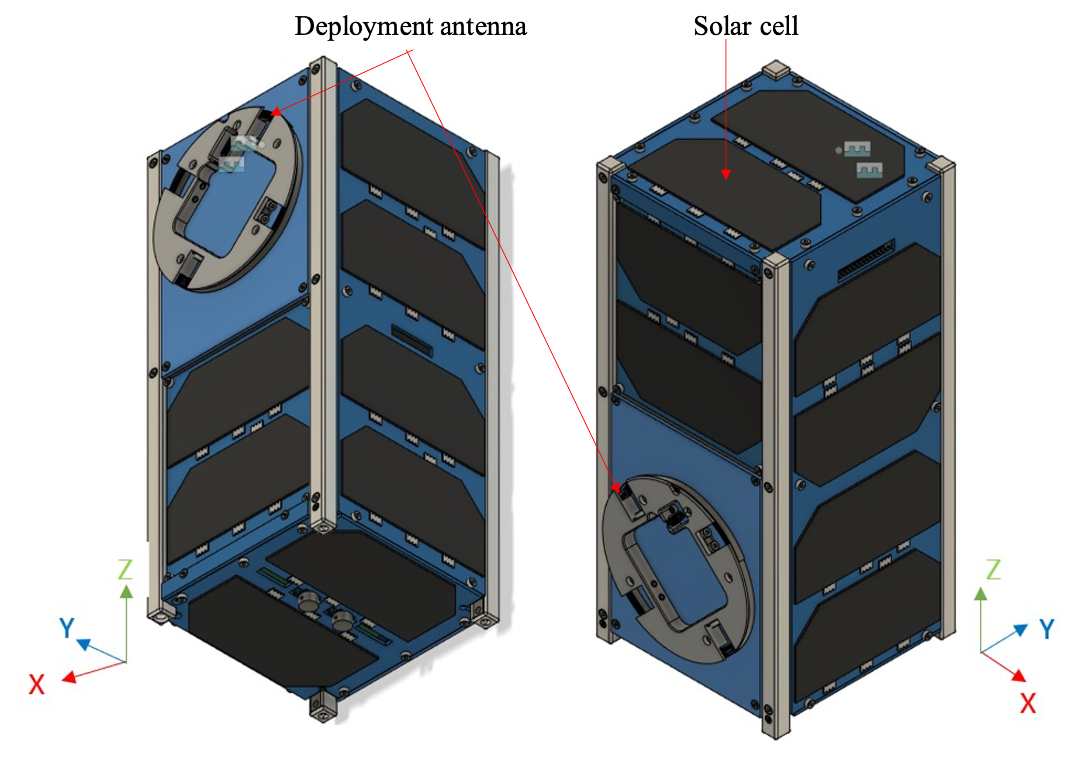

Figure 3.1-1 DRAGONFLY stowed configuration

Antenna

c

Antenna

Solar Cell

Z

X

Y

X

Y

Z

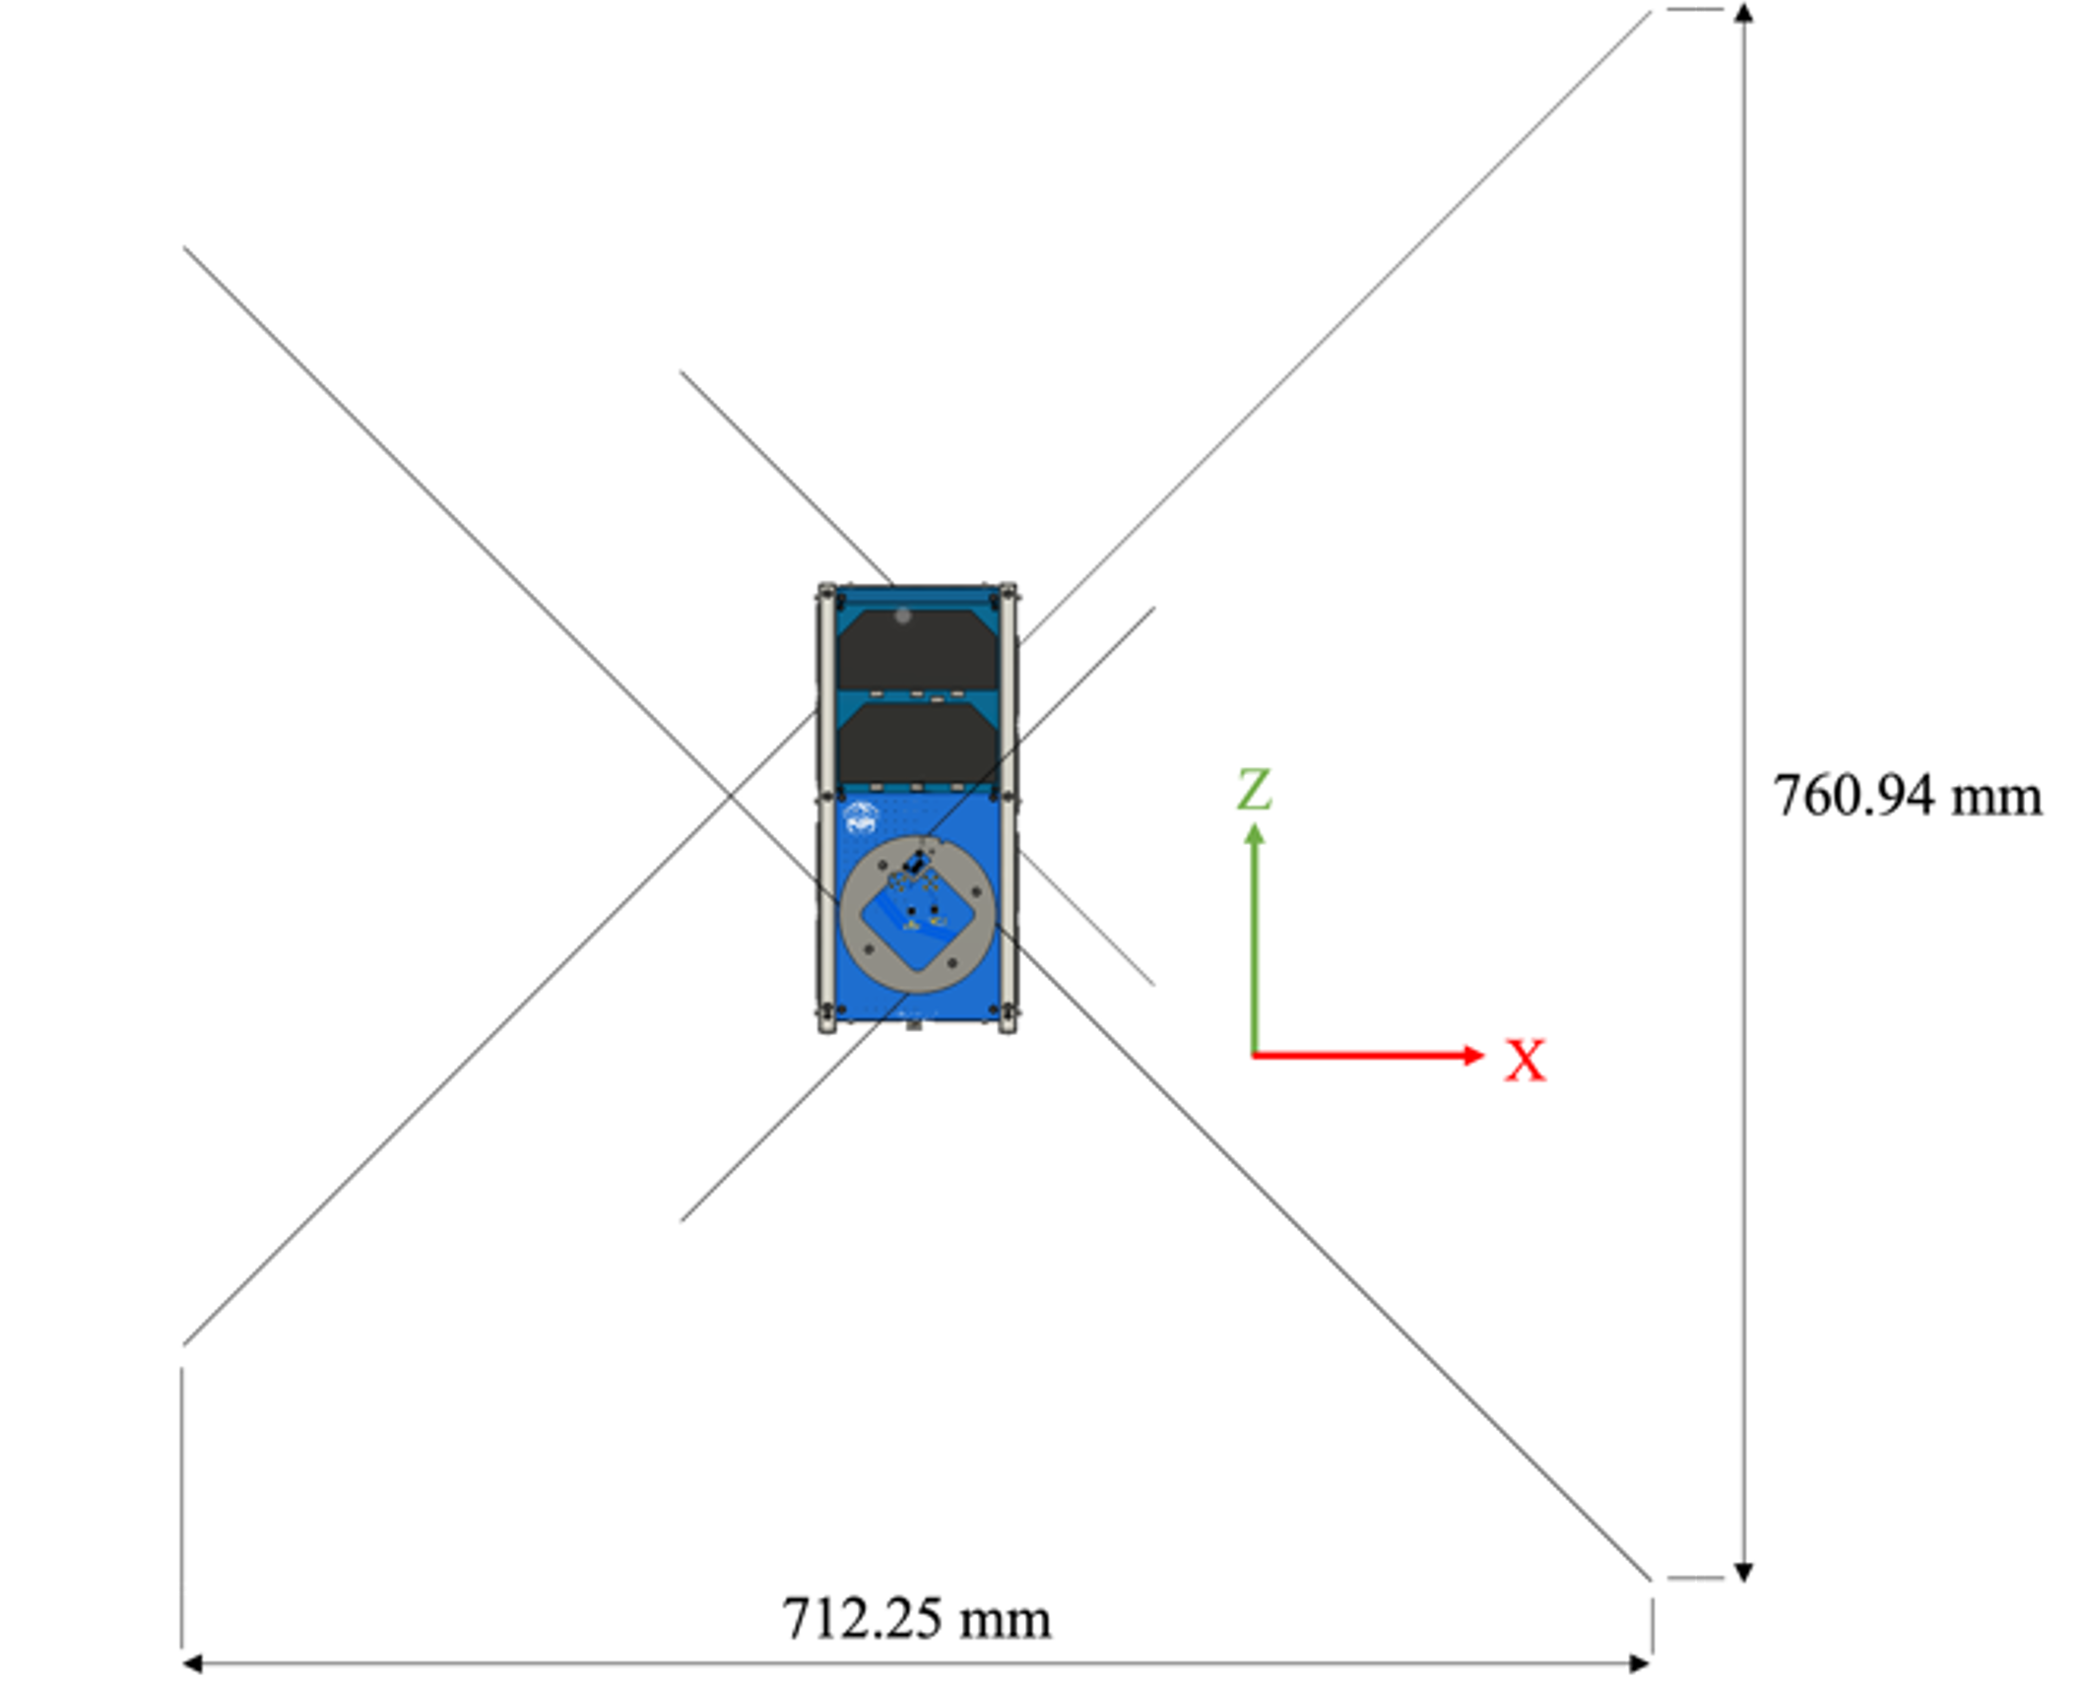

Figure 3.1-2 DRAGONFLY deployment configuration

The system block diagram of DRAGONFLY is shown in Figure 3.1-3. The OBC (On Board Computer) / EPS (Electrical Power System), FAB (Front Access Board), BPB (Backplane Board) design is based on BIRDSBus (refer to <https://birdsopensource.github.io/>).

The following is information for BIRDSBus used in DRAGONFLY:

* The used BIRDSBus: OBC/EPS, FAB, BPB
* BIRDSBus version: version 4
* Modification: Yes – Since the satellite size was set to 2U, the outer panels on the X and Y sides were divided into two panels, upper and lower. BIRDSBus had a blocking diode on the FAB. However, since the ±X panel is divided into upper and lower panels, blocking diodes are placed on each panel and diodes for ±X on the FAB are replaced with 0 ohm resistors. Diodes on the panel are identified as an inhibitor of battery over-discharge.

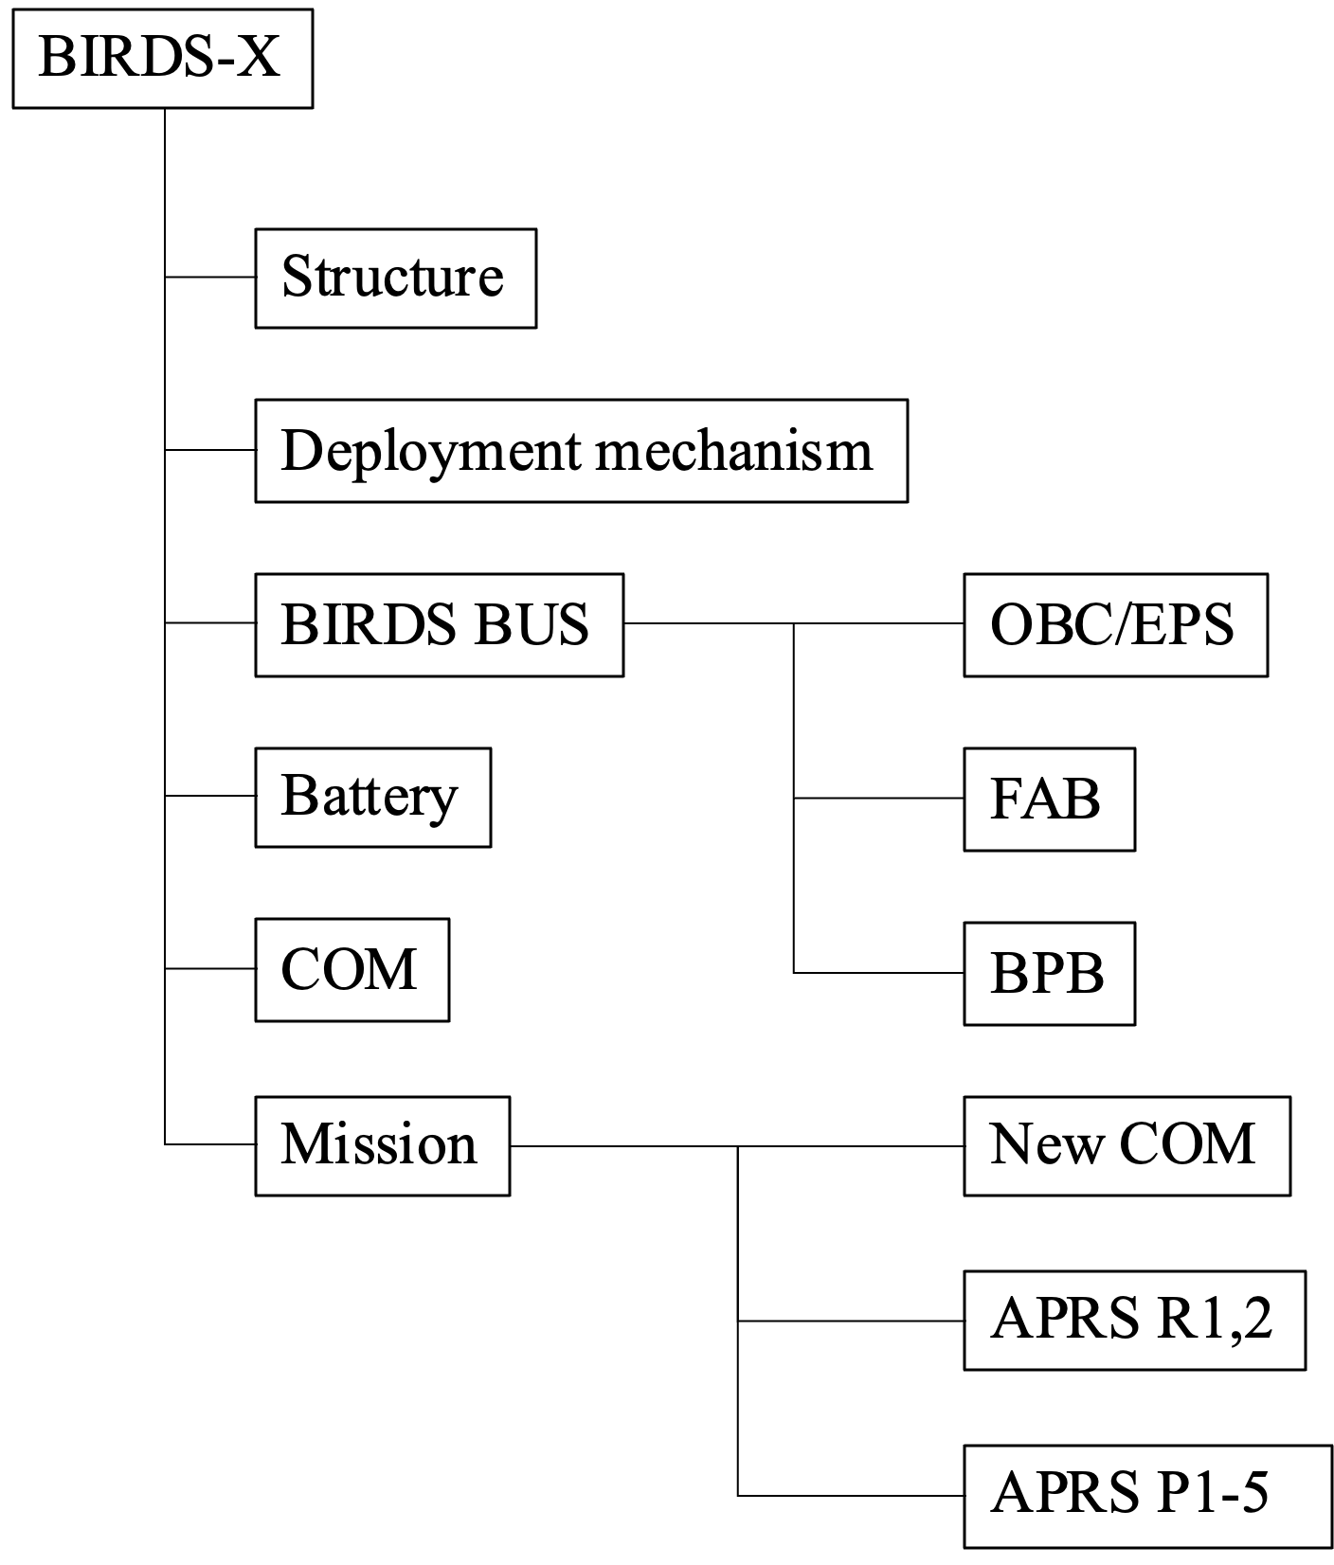

Figure 3.1-3 The system block diagram of DRAGONFLY

* 1. Design Different from Baseline  
      In this section, design difference of DRAGONFLY from BIRDS-5 (PearAfricaSat-1 and ZIMSAT-1) in Applicable Document (2) is described.  
     1. Structure  
        Figure 3.2.1-1 and Figure 3.2.1-2 shows the primary structure (4 rails and 3 frames) and internal configuration, respectively. The size is 2U, but the whole structure design is different. The primary structure is made of Aluminum alloy A6061-T6 and all four rails are hard anodized. Other structural parts are treated with Alodine. These parts are not welded, forged, cast or quenched.

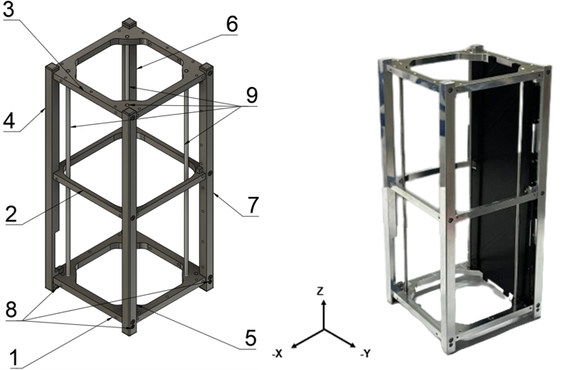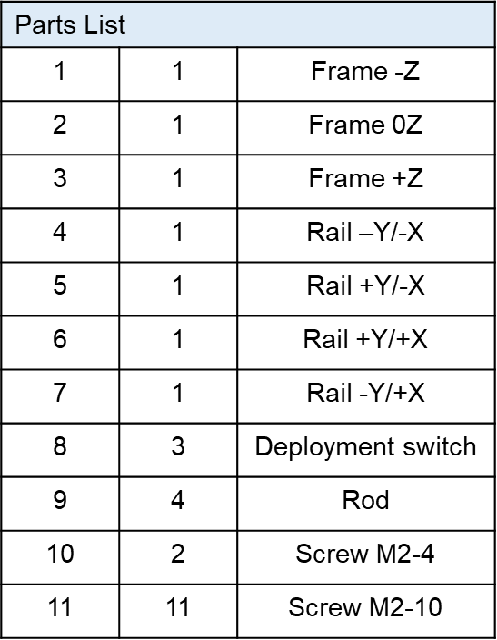

Figure 3.2.1-1 The primary structure (4 rails and 3 frames)

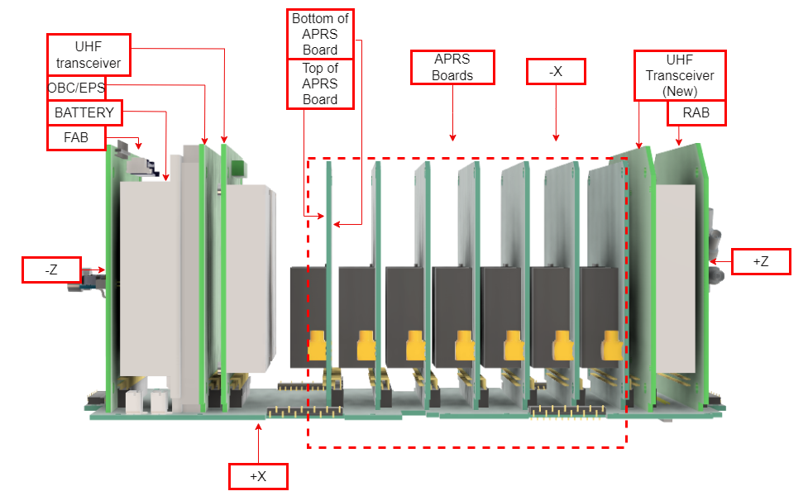Figure 3.2.1-2 The internal configuration

* + 1. Deployment Mechanism  
        DRAGONFLY has eight deployable antennas, which are dipole type for UHF and VHF transmitter. Figure 3.2.2-1 shows stowed antenna configuration. The parts used (UHF antenna (225mm x 3mm x 0.3mm), VHF antenna (487mm x 3mm x 0.3mm), wire (PE line), heat cutter) are the same as BIRDS-5. On the other hand, we created a new Teflon antenna deployment mechanism to prevent the wire from getting caught in the antenna after cutting. In BIRDS-5, the UHF antenna was covered by a VHF antenna. At DRAGONFLY, the antenna is held in place by a Kapton tape extension attached to the tip of the VHF antenna; the UHF and another VHF antenna are covered by this. Kapton tape extension is created by laminating two wires with Kapton tape. Two independent wires are tied to this Kapton tape extension and to the antenna tip and antenna deployment mechanism with two half-hitch knots. Figures 3.2.2-2 through 3.2.2-5 show the details. The contact area with the other parts is chamfered and covered with Kapton tape. (See BIRDS-X Assembly Drawing and BIRDS-X Assembly Procedure Step #14 in the details.)　Collision analysis immediately after deployment from J-SSOD is performed. (See Appendix C-9.)

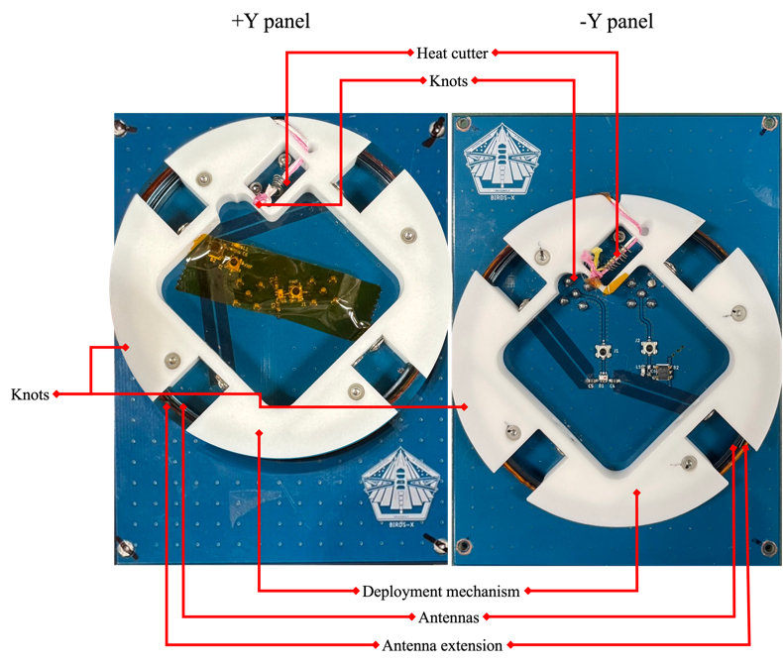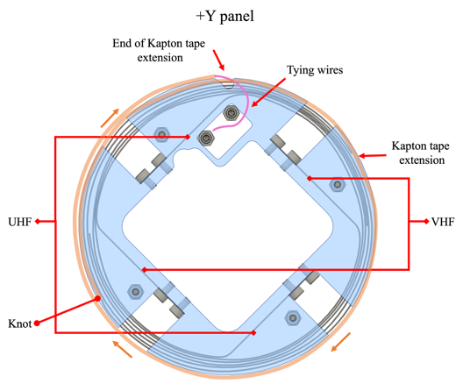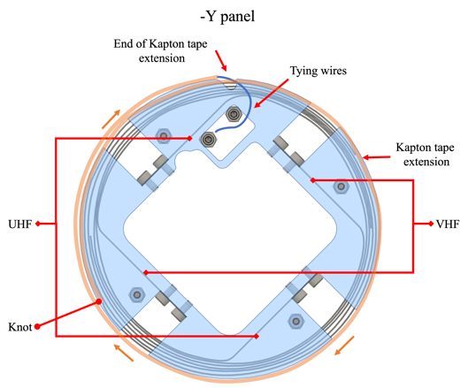  
Figure 3.2.2-1 Stowed antenna configuration

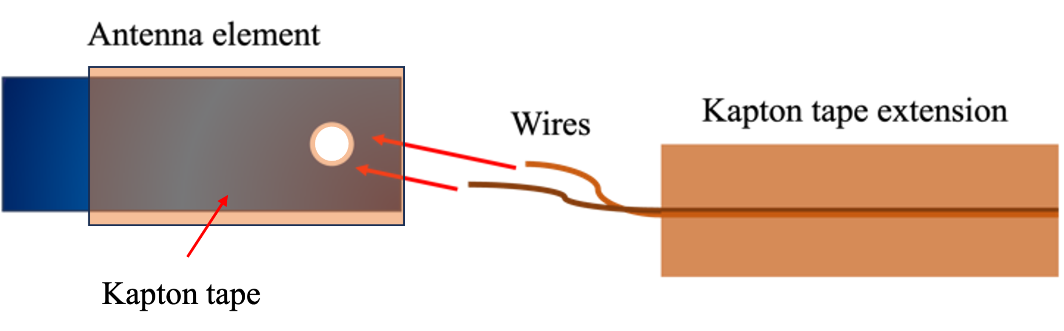

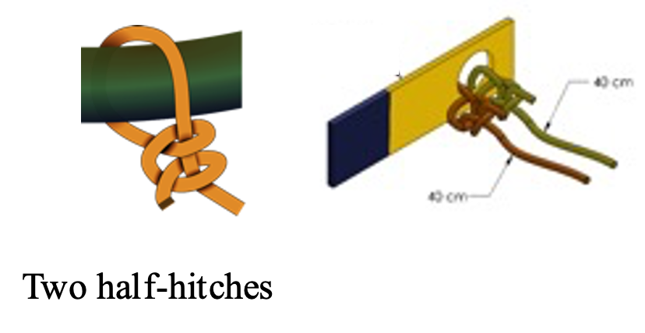

Figure 3.2.2-2 Connection between antenna element and Kapton tape extension (Step #1)

In Figure 3.2.2-2, Two half-hitches represent how the Kapton tape extension is secured to the deployment mechanism.

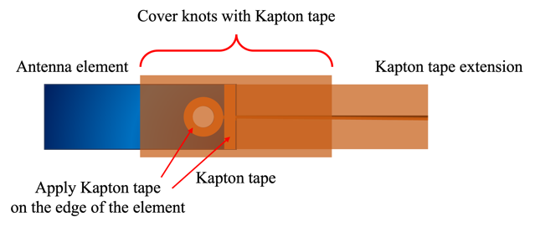

Figure 3.2.2-3 Connection between antenna element and Kapton tape extension (Step #2)

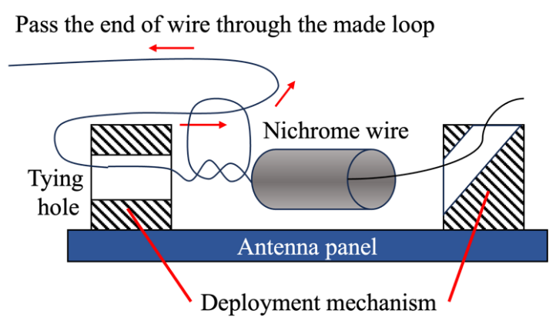

Figure 3.2.2-4 How to tie the wires

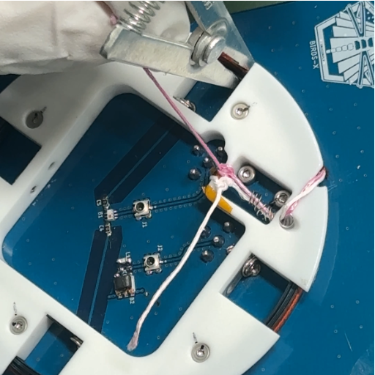

Figure 3.2.2-5 Locations where the wires are secured to the deployment mechanism

* + 1. Electrical Power System  
       Electrical power system uses BIRDS-Bus. Inhibit control is based on BIRDS-Bus. Six Nickel Metal Hydride - NiOOH/metal alloy/KOH batteries are connected by three-series and two-parallel. The CubeSat does not use wet Electrolytic Capacitor in EPS. For ±X solar panels, a diode on the panel is used instead of a diode on the FAB to inhibit battery over-discharge.

DARGONFLY also has three deployment switches on the -Z rail ends whose specification and install/actuating position is shown in Table 3.2.3-1 and Figure 3.2.3-2, respectively.

Solar cell power analysis is performed to verify that OBC is not activated in JEM. (Refer to Appendix C-6.)

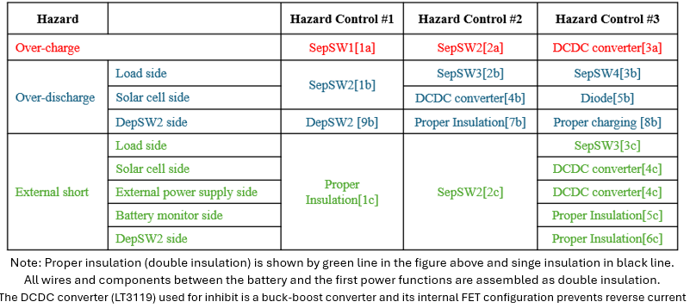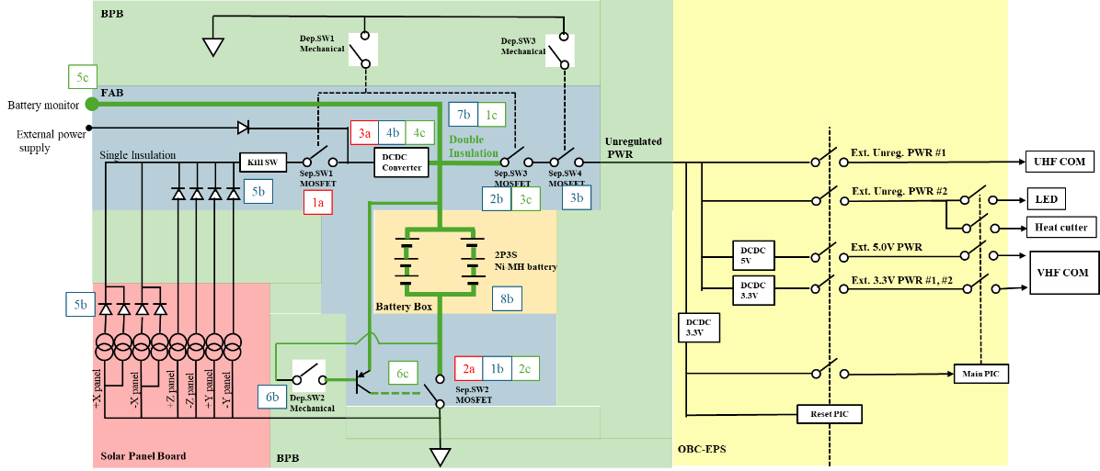

Figure 3.2.3-1 Electrical Power System Schematic for hazard controls

Table 3.2.3-2 Deployment switch specification

|  |  |
| --- | --- |
| Manufacture / Part No. | C&K inc. / DEP012 |
| Rated current (A) | 0.1 |
| Rated Voltage (V) | 12 |
| Operating Temperature (℃) | -40 - +85 |
| Releasing Force (N) | 0.25* |

* DRAGONFLY also has a spring plunger whose spring force is 0.6 N. Therefore the total spring force is 1.35 N, which meets Applicable Document (3).

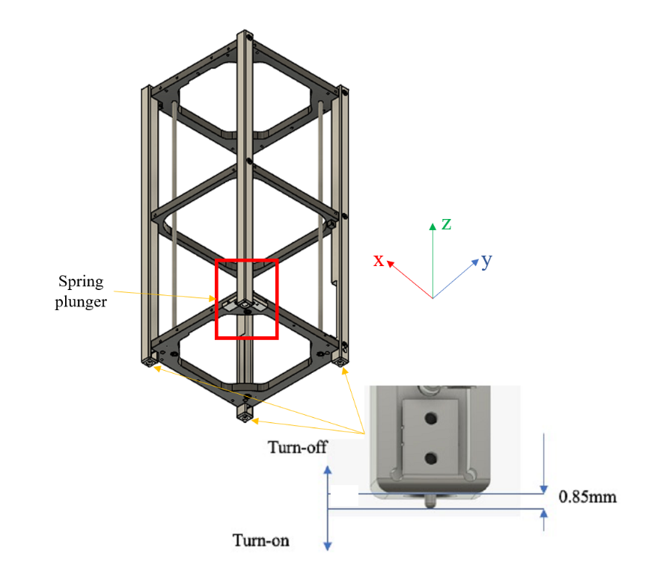

Figure 3.2.3-2 Deployment switch install and actuating position

* + 1. Communication System  
        The Communication system transmits and receives UHF and VHF.

The UHF Communication system receives command uplink from the ground station and sends telemetry/housekeeping to the ground station. The UHF transmitter is the same as BIRDS-5 (437.375 MHz with max transmission power of 0.96 W).

The VHF Communication system receives data from the ground sensors and sends these data to the ground station. The VHF transmitter is the same as BIRDS-5 (145.825 MHz with max transmission power of 0.6 W).

The operating sequence after deployed from ISS is also the same as BIRDS-5 as shown below:  
1) Deployment switches are closed.

2) OBC starts operation.

3) OBC waits for 2,000 seconds and confirms that batteries generate enough output voltage.

4) OBC activates the heater circuit connecting to nichrome wire for antenna deployment mechanism.

5) The heater circuit stops after antenna deployment.

6) The transceiver turns ON after antenna deployment and commands can be received. CW beacon is transmitted.

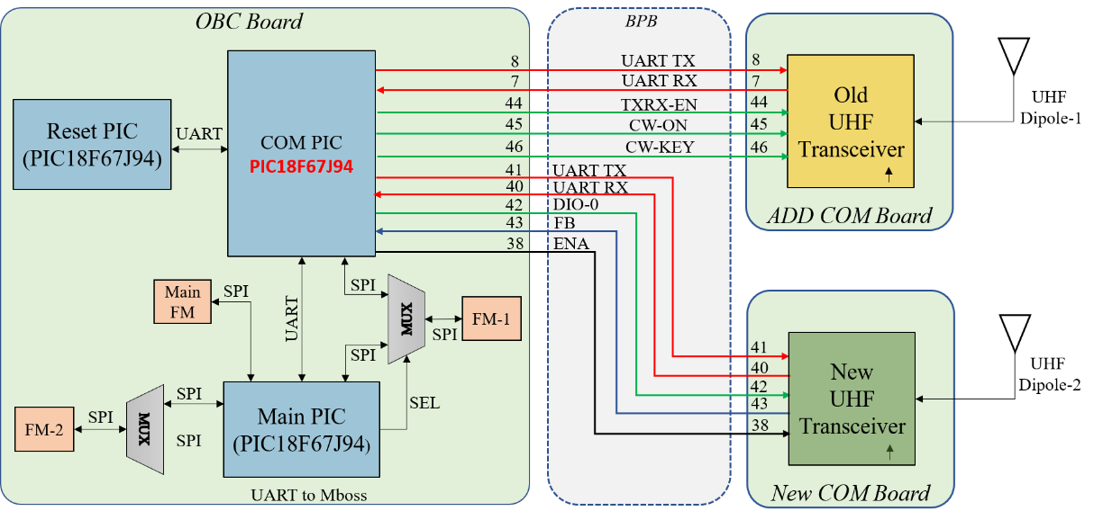

**Figure 3.2.4-1 UHF Communication Subsystem Block Diagram**

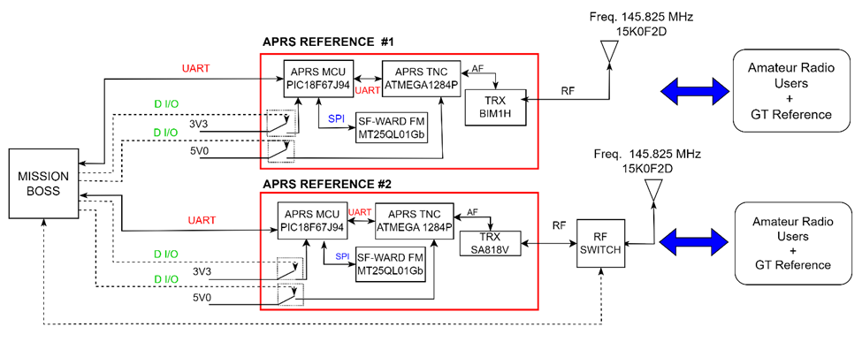

**Figure 3.2.4-2 VHF Communication Subsystem Block Diagram**

* + 1. Mission

3.2.5.1 LED

DRAGONFLY has 5 LEDs the +X solar panel. The LEDs serve to provide an indication and confirm that the satellite has turned on after antenna deployment by observation from the ISS. The location of the LEDs on the satellite can be found as shown in Figure 3.2.5.1-1. Table 3.2.5.1-1 shows the characteristics of the LEDs used.

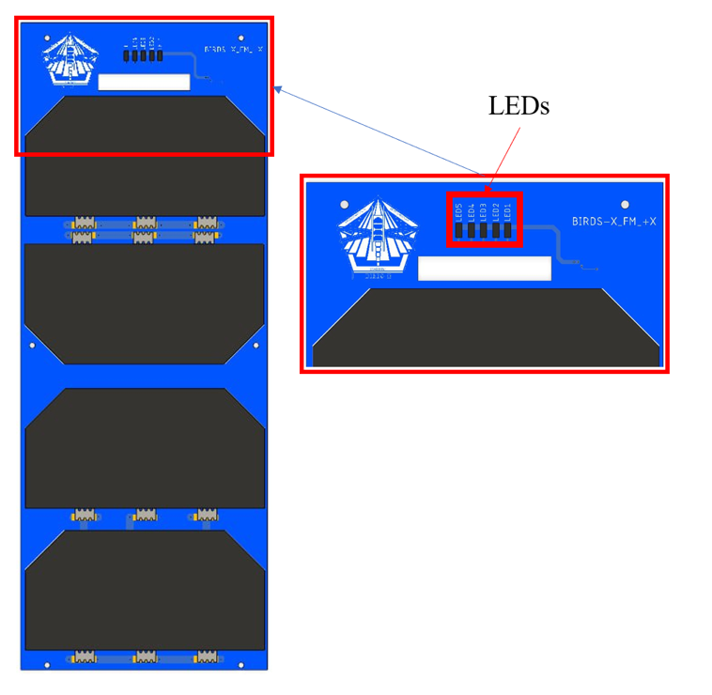

**Figure 3.2.5.1-1 Communication Subsystem Block Diagram**

**Table 3.2.5.1-1 LED Properties**

|  |  |
| --- | --- |
| Parts Number | APTD1608URCK |
| Manufacturer | Kingbright |
| Wavelength at Peak Emission IF = 20mA | 645nm |
| Operating/Storage Temperature | -40°C to +85°C |
| Luminosity lv | 800 mcd |

The results of the brightness analysis of the LEDs used are shown below.

Isotropic light source, the luminous flux Φv in lumens (lm) is equal to the luminosity *I*v in millicandela (mcd), times the solid angle *Ω* in steradians (sr) divided by 1000:

$Φ_{v\left(lm\right)}=I_{v(mcd)}×Ω_{(sr)}$/1000

The solid angle *Ω* in steradians (sr) is equal to 2 times π times 1 minus cosine of half the apex angle *θ* in degrees (°):

$$Ω_{(sr)}=2π\left(1-\cos\left(\frac{θ}{2}\right)\right)$$

The luminous flux Φv in lumens (lm) is equal to the luminosity *I*v in millicandela (mcd), times 2 times π times 1 minus cosine of half the apex angle *θ* in degrees (°) divided by 1000:

$$Φ_{v(lm)}=I_{v(mcd)}×\frac{\left(2π\left(1-\cos\left(\frac{θ}{2}\right)\right)\right)}{1000}$$

Luminosity of the LED used is 800 mcd and the apex angle is 60°. The error of luminosity is 15%. Therefore, the maximum luminosity is 920 mcd.

So, luminous flux is

$$Φ_{v(lm)}=920×\frac{\left(2π\left(1-\cos\left(\frac{60}{2}\right)\right)\right)}{1000}=0.7744 [lm]$$

To convert Lumens to Nits divide the number of Lumens by 3.426. Luminance of the LED used is 0.226 nits. Since 5 LEDs are used, if these lights overlap, the maximum luminance is 1.130 nits. This value is very small compared to the required 10,000nits, and the LED is not a hazard item.

1. Launch Configuration and Operation  
    Launch configuration and operation until DRAGONFLY is deployed from ISS is the same as Applicable Document (2).
2. Hazard Analysis Result
   1. Hazard Identification and Assessment  
       There is no new identified hazard. DRAGONFLY has no high-voltage (>32 V) circuit, Electrical Shock (BIRDS5-UNQ-05) is not applicable to DRAGONFLY hazard analysis. All the other hazards based on Applicable Document (2) are applicable to DRAGONFLY.  
       The difference of assessment from HR in Applicable Document (2) is the followings:  
      - No need for the camera lens and filter assessment in the verification of BIRDS5-UNQ-01, since the satellite does not use a camera,  
      - No need for magnetic field assessment in the verification of STD-12, because the satellite does not use the magnet and the magnetic torquer,

The hazard controls and verification method in Applicable Document (2) can be applied to DRAGONFLY, except for HR described in section 5.2. The verification result is shown in Appendix B-1 “Baseline Hazard Report Verification Matrix”.

* 1. Modification of Hazard Report  
      The satellite is equipped with a +X solar panel with 5 LEDs. IVA Crew Exposure to Light Amplification by Stimulated Emission of Radiation (LASER) and/or Incoherent Electromagnetic Radiation Emissions evaluated according to the Standard Hazard approach. Refer to Appendix B-3, SHR-7.

The Unique Hazard Report for Impact / Collision to ISS due to inappropriate CubeSat deployment from J-SSOD by inadvertently deployment (BIRDS5-UNQ-04) need to be modified because the deployable antenna design is changed. Refer to Appendix B-2"BIRDSX-UNQ-04".

Appendix A. Abbreviation and Acronyms

COTS Commercial Off-The-shelf

FEA Finite Element Analysis

FEM Finite Element Method

FS Factor of Safety

ISS International Space Station

J-SSOD JEM Small Satellite Orbital Deployer

JEM Japanese Experiment Module

MIUL Materials Identification Usage List

MS Margin of Safety

MUA Material Usage Agreement

NASA National Aeronautics and Space Administration

SAR Safety Assessment Report

COM Communicator

JAXA Japan Aerospace Exploration Agency

MCU Micro Control Unit

MS Margins of Safety

MUA Material Usage Agreement

NDE Non-destructive Evaluation

PIC Peripheral Interface Controller

Appendix B-1. Baseline Hazard Report Verification Matrix

Appendix B-1. Baseline Hazard Report Verification Matrix

| No. | Hazard Title | Verification No. | Verification Document | Status | Note |
| --- | --- | --- | --- | --- | --- |
| SHR-1 | Flammable Material | V-1.1(a) | **MIUL**  BIRDSX-MIUL-01 | Closed  (January 10, 2024) |  |
| SHR-2 | Material Offgassing | V-2(a) | **MIUL**  BIRDSX-MIUL-01 | Closed  (January 10, 2024) |  |
| SHR-3 | Inadvertent Release of Battery Electrolyte | V-3(b) | **HMST**  Appendix C-3  Common Battery HMST | Closed  (January 10, 2024) |  |
| SHR-5 | A Crew Exposure to Mechanical Hazards | V-5.1(a) | **設計図面**  BIRDSX-AD-01 | Closed  (January 26, 2024) |  |
| V-5.1(b) | **シャープエッジ検査記録**  BIRDSX-SEIR-01 | To be closed at Phase III |  |
| SHR-10 | Injury/Damage as a Result of Improper Power Distribution Circuitry and Circuit Protection Devices | V-10.1(a) | **JAXAチェックリストに従った評価**  Appendix C-7 (BIRDSX-STD-Attachment-1) | <For phase 0/I/II>  Closed  (March 23, 2024)  <For phase III>  To be closed at Phase III |  |
| **JAXAチェックリストに従った評価**  BIRDSX-VTL-01 | Closed to VTL |
| V-10.1(b) | **ワイヤディレーティング評価(解析)**  Appendix C-8 (BIRDSX-STD-Attachment-2) | Closed  (April 10, 2024) |  |
| V-10.1(c) | **ワイヤディレーティング評価(検査)**  BIRDSX-STD-Attachment-3 | To be closed at Phase III |  |
| SHR-12 | Non-Ionizing Radiation Interference | V-12.1 | **電磁放射、感受性評価**  BIRDSX-STD-Attachment-4 | Closed  (March 22, 2024) | DRAGONFLY has no permanent magnet. Therefore, verification is needed just for FET susceptibility. |
| V-12.2 | **小型衛星共通の試験不要となるTIA**  Appendix C-4 (TIA#1416A) | Closed  (May 30, 2014) |  |
| V-12.4 | **OE-14-002適合性評価**  BIRDSX-STD-Attachment-5 | Closed  (January 28, 2024) |  |
| **SSP50005適合性評価(SRAG評価シート)**  Appendix C-5 (Hazard Analysis Verification  Space Radiation Analysis Group (SRAG)) | Closed  (January 29, 2024) |
| BIRDS5-UNQ-01 | Structure Failure | 1.1-1(1) | **梱包検査(SVTL)**  BIRDSX-VTL-01 | Closed to VTL |  |
| 1.1-1(2) | **質量確認**  BIRDSX-IVR-01 | To be closed at Phase III |  |
| 1.1-2 | **構造解析書**  BIRDSX-SR-01 | Closed  (May 28, 2024) |  |
| 1.2 | **MIUL**  BIRDSX-MIUL-01 | Closed  (January 10, 2024) |  |
| 1.3 | **構造フラクチャコントロール評価フォーム**  BIRDSX-FCE-01 | Closed (June 17, 2024) |  |
| **構造フラクチャコントロール評価フォーム**  BIRDSX-FCE-02 | To be closed at Phase III |  |
| 1.4(1) | **構造フラクチャコントロール評価フォーム**  BIRDSX-FCE-01 | Closed (June 17, 2024) |  |
| **構造フラクチャコントロール評価フォーム**  BIRDSX-FCE-02 | To be closed at Phase III |  |
| 1.4(2) | **振動試験報告書**  BIRDSX-VT-01 | To be closed at Phase III |  |
| 1.5(1) | **組立手順**  BIRDSX-AP-01 | Closed  (June 7, 2024) |  |
| 1.5(2) | **組立記録**  BIRDSX-AR-01 | To be closed at Phase III |  |
| 1.5(3) | **振動試験報告書**  BIRDSX-VT-01 | To be closed at Phase III |  |
| 1.6(1) | **設計図面**  BIRDSX-AD-01 | Closed  (January 26, 2024) |  |
| 1.6(2) | **組立記録**  BIRDSX-AR-01 | To be closed at Phase III |  |
| 2.1.2 | **振動試験報告書**  BIRDSX-VT-01 | To be closed at Phase III | The verification target is 16 solar cells. |
| BIRDS5-UNQ-02 | Battery Leakage / Rupture | 1.1(1)  1.1(2)  1.1(3)  1.1(4)  1.2-1  1.2-2(1)  1.2-2(2)  1.3(1)  1.3(2)  1.4-1(1)  1.4-1(2)  1.4-1(3)  1.4-2(1)  1.4-2(2)  1.5 | **・回路設計**  BIRDSX-EP-01 | Closed  (March 22, 2024) | Modify the verification method to change the blocking diode used for inhibit. |
| **・バッテリ検証試験**  BIRDSX-BVR-01 | To be closed at Phase III |  |
| **・絶縁検査**  **・保護装置機能試験**  BIRDSX-IFTR-01 | To be closed at Phase III |  |
| **・リーク電流解析**  Appendix C-10 (Leakage current evaluation) | Closed  (March 22, 2024) |  |
| **・引渡し前充電量確認**  **・絶縁検査**  BIRDSX-VTL-01 | Closed to VTL |  |
| BIRDS5-UNQ-03 | Exposure of the ISS to Excessive Levels of EMI radiation and RF radiation | 1.1 | **インヒビット機能試験**  BIRDSX-IFTR-01 | To be closed at Phase III | The UHF communication system meets the criteria in SSP30237 and SSP50005 and is assessed in STD-12.  The VHF communication system meets the criteria in SSP50005, do not meets the criteria in SSP30237 and is assessed in UNQ-03. |
| BIRDS5-UNQ-04 | Impact / Collision to ISS due to inappropriate CubeSat deployment from J-SSOD by inadvertently-deployment | 1.1-1(1) | **インヒビット機能試験**  BIRDSX-IFTR-01 | To be closed at Phase III |  |
| 1.1-1(2) | **絶縁検査**  BIRDSX-IFTR-01 | To be closed at Phase III |  |
| 1.1-2 | **構造フラクチャコントロール評価フォーム**  BIRDSX-FCE-01 | Closed (June 17, 2024) |  |
| **構造フラクチャコントロール評価フォーム**  BIRDSX-FCE-02 | To be closed at Phase III |
| 1.2 | **設計図面**  BIRDSX-AD-01 | Closed  (January 26, 2024) |  |
| **組立記録**  BIRDSX-AR-01 | To be closed at Phase III |  |
| BIRDS5-UNQ-05 | Electrical Shock | 1.1-1  1.1-2  1.1-3 | N/A | N/A | DRAGONFLY has no high voltage system. |

|  |  |  |
| --- | --- | --- |
| **Signature (Effective for this “Baseline Hazard Report Verification Matrix”)** | | |
| APPROVAL | HARDWARE ORGANIZATION  (Printed Name, Signature, Date) | ISS SAFETY REVIEW PANEL (ISRP)  (Printed Name, Signature, Date) |
| Phase 0/I |  |  |
| Phase II |  |  |
| Phase III |  |  |

Appendix B-2. Unique Hazard Report

**5項で識別されたユニークなHRを示す。(基本的には通常のSARと同様、フォームISS_OE_851で添付すること。記載方法はJSX-2009032「安全評価報告書作成要領」参照。)**

Appendix B-3. Standard Hazard Report

**5項で識別されたユニークなHRを示す。(基本的には通常のSARと同様、フォームISS_OE_851で添付すること。記載方法はJSX-2009032「安全評価報告書作成要領」参照。)** 



**Appendix C-1 Structure Fracture Control Evaluation Form**

**Appendix C-2 Battery Description Form**

**Appendix C-3 Toxicity Analysis (HMST)**





**Appendix C-4 ISS EME Tailoring/Interpretation Agreement**



**Appendix C-5 Hazard Analysis Verification for Space Radiation Analysis Group (SRAG)**



**Appendix C-6 Verification of solar cell power**

Since walls of J-SSOD-R launch case are transparent, if there are not enough inhibits and all inhibits located on the closed circuit from solar cell to load are accidentally closed, there is possibility to generate power with solar cells and activate some function of satellite which may cause hazard. To prove this function are not activated with the power generated by light inside JEM, it is required to show the power for activating the function is larger than the generated power with solar cells.

[Presupposition]

All we got from JAXA are shown below.

1. Graph of Relative Intensity of 3 mode of GLA (General Luminaire Assembly) (Figure 5)
2. Value of Max Illuminance at 1m from deck*: 1,400 [lx]

*There are 8 GLA in every 1m on each standoff of AFT/OVHD and FWD/OVHD inside JEM PM as shown in Figure 6. It is little difficult to calculate the distance from all GLA to work space, so this value was calculated by considering the work space surrounded by 2 GLA which has 8 times power of real GLA for each are located on AFT/OVHD and FWD/OVHD. Thus, it is very conservative value.

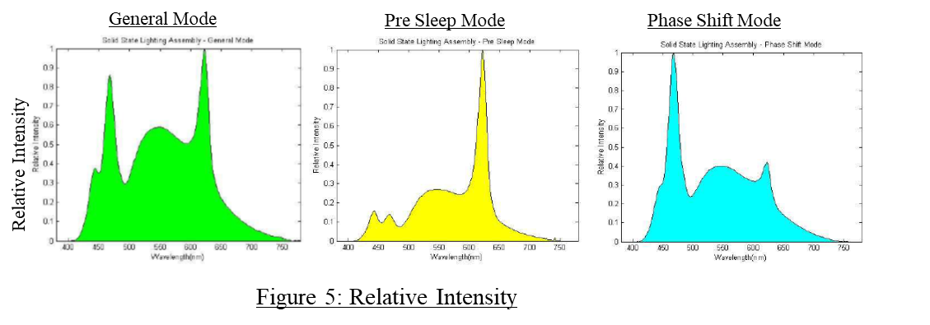

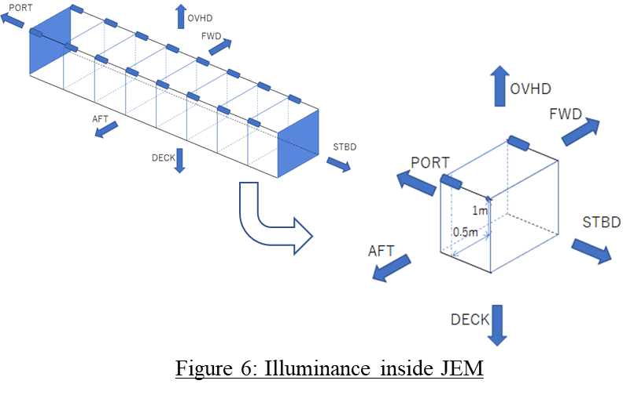

Illuminance is calculated by the following formula.

Illuminance[lx] = ∑ (683[lm/W] x Luminosity Function @each wave length x Irradiance [W/m2)@each wave length)

= ∑ (683 x A x Relative Intensity @each wave length x Irradiance [W/m2)@each wave length)

683: Max Luminous Sensitivity. Luminosity Function: shown right. It is defined as CIE1924., A: Absolute Irradiance/Relative Intensity

To get total irradiance [W/m2] of all wavelengths of the GLA, we have to integrate Irradiance @each wavelength. And, to get absolute Irradiance@ each wavelength, factor A (Absolute Irradiance/Relative Intensity) is needed. With the value read from each relative intensity graph, luminosity function and Max Illuminance 1400[lx], the whole irradiance was calculated, and the result are shown below.

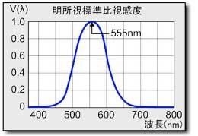

General Mode

A: 3.32 x 10^-2

Irradiance: 4.47 [W/m2]

Pre-Sleep Mode

A: 7.26 x 10^-2

Irradiance: 4.19 [W/m2]

Phase Shift Mode

A: 5.32 x 10^-2

Irradiance: 4.69 [W/m2]

**[Generated Power]**

Spec, number of solar cells of DRAGONFLY is shown below.

Area of each solar cell: 0.003 [m2]

Number of solar cells: 16

Conversion Efficiency: 30 [%] * *Exact value of this solar cells is unknown. So, theoretical max value is used.

The generated power on each mode is calculated as shown below.

General Mode

Generated Power : 4.47 x 0.003 x 16 x 0.3 = 0.0643[W]

Pre-Sleep Mode

Generated Power : 4.19 x 0.003 x 16 x 0.3 = 0.0603[W]

Phase Shift Mode

Generated Power : 4.69 x 0.003 x 16 x 0.3 = 0.0675[W]

**[Required Power for Activate Function]**

The function of the DRAGONFLY whose accidental activation may cause hazard are a heat cutter and a RF radiation. The heat cutter is activated by the OBC.

The minimum power required to operate the Reset PIC, which controls the power supply to the OBC and COM is shown below.

Activation of Reset PIC: 0.380 [W]

**Conclusion**

The required power for activating the het cutter and the COM is very larger than power generated with solar cells with light inside ISS, even Reset PIC cannot be activated with power generated with solar cells. Thus, there is no possibility to cause hazard by this function activation.

**Appendix C-7 Implementation plan extracted from JAXAʼs checklist**

**Appendix C-8 Selection of Wires and Circuit Protection Devices**

**Appendix C-9 Collision analysis immediately after deployment from J-SSOD**

The release velocity of CubeSat is assumed to be 0.77 m/s which is the lower limit (JX-ESPC-101132-D1 Table4.3.1.2.2-1). The time until the CubeSat's heat cutter is turned on and the antenna is deployed is more than 20 s. The distance (X1) from J-SSOD (X1) until the satellite is released and the antenna deploys is X1=0.77*20=15.4 m.

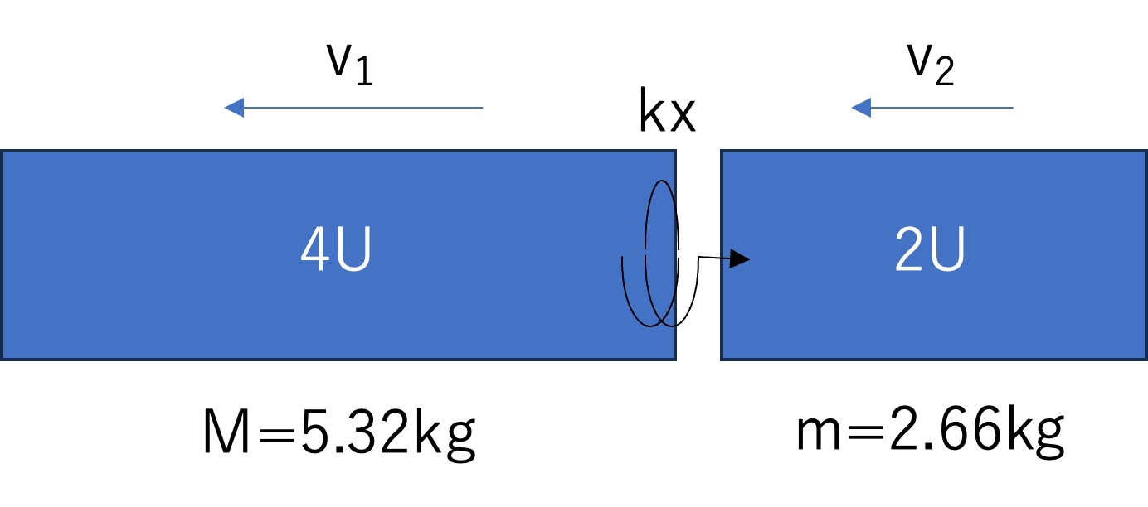

**Figure 6.1-4 CubeSat separation velocity analysis**

The satellite deployer can release up to 6U. Since this satellite is a 2U CubeSat, it is assumed that a 4U CubeSat is placed in front of it. The mass of 2U is m=2.66 [kg], the velocity after release is v2 [m/s], the mass of 4U is M=5.32 [kg], and the velocity is v1 [m/s]. The spring coefficient of the spring between the CubeSats is k, and the spring stroke x [m] is 0.75x10-3 [m]. The minimum spring force kx is 1.05[N].

The following formula holds from the laws of conservation of momentum and energy.

$$Mv_{1}+mv_{2}=0$$

$$\frac{1}{2}Mv_{1}^{2}+\frac{1}{2}mv_{2}^{2}=\frac{1}{2}kx^{2}$$

Therefore,

$$\frac{1}{2}5.32×v_{1}^{2}+\frac{1}{2}2.66{×4v}_{1}^{2}=\frac{1}{2}1.05×0.75×{10}^{-3}$$

$$v_{1}=0.007\left[m/s\right], v_{2}=-0.014[m/s]$$

The separation speed v1-v2 between CubeSats after the CubeSats are released is 0.021 [m/s]. CubeSat takes more than 20 seconds after all isolation switches are turned on until the antenna deploys due to a malfunction. The distance between CubeSats after 20 seconds from CubeSat release is 0.42 [m].

When the deployable antenna is deployed, the distance from the ±Z rail end of the CubeSat to the antenna end is 0.267 [m]. From the above, even if the deployable object is erroneously deployed immediately after the CubeSat is released, it will not affect the J-SSOD or other CubeSats.

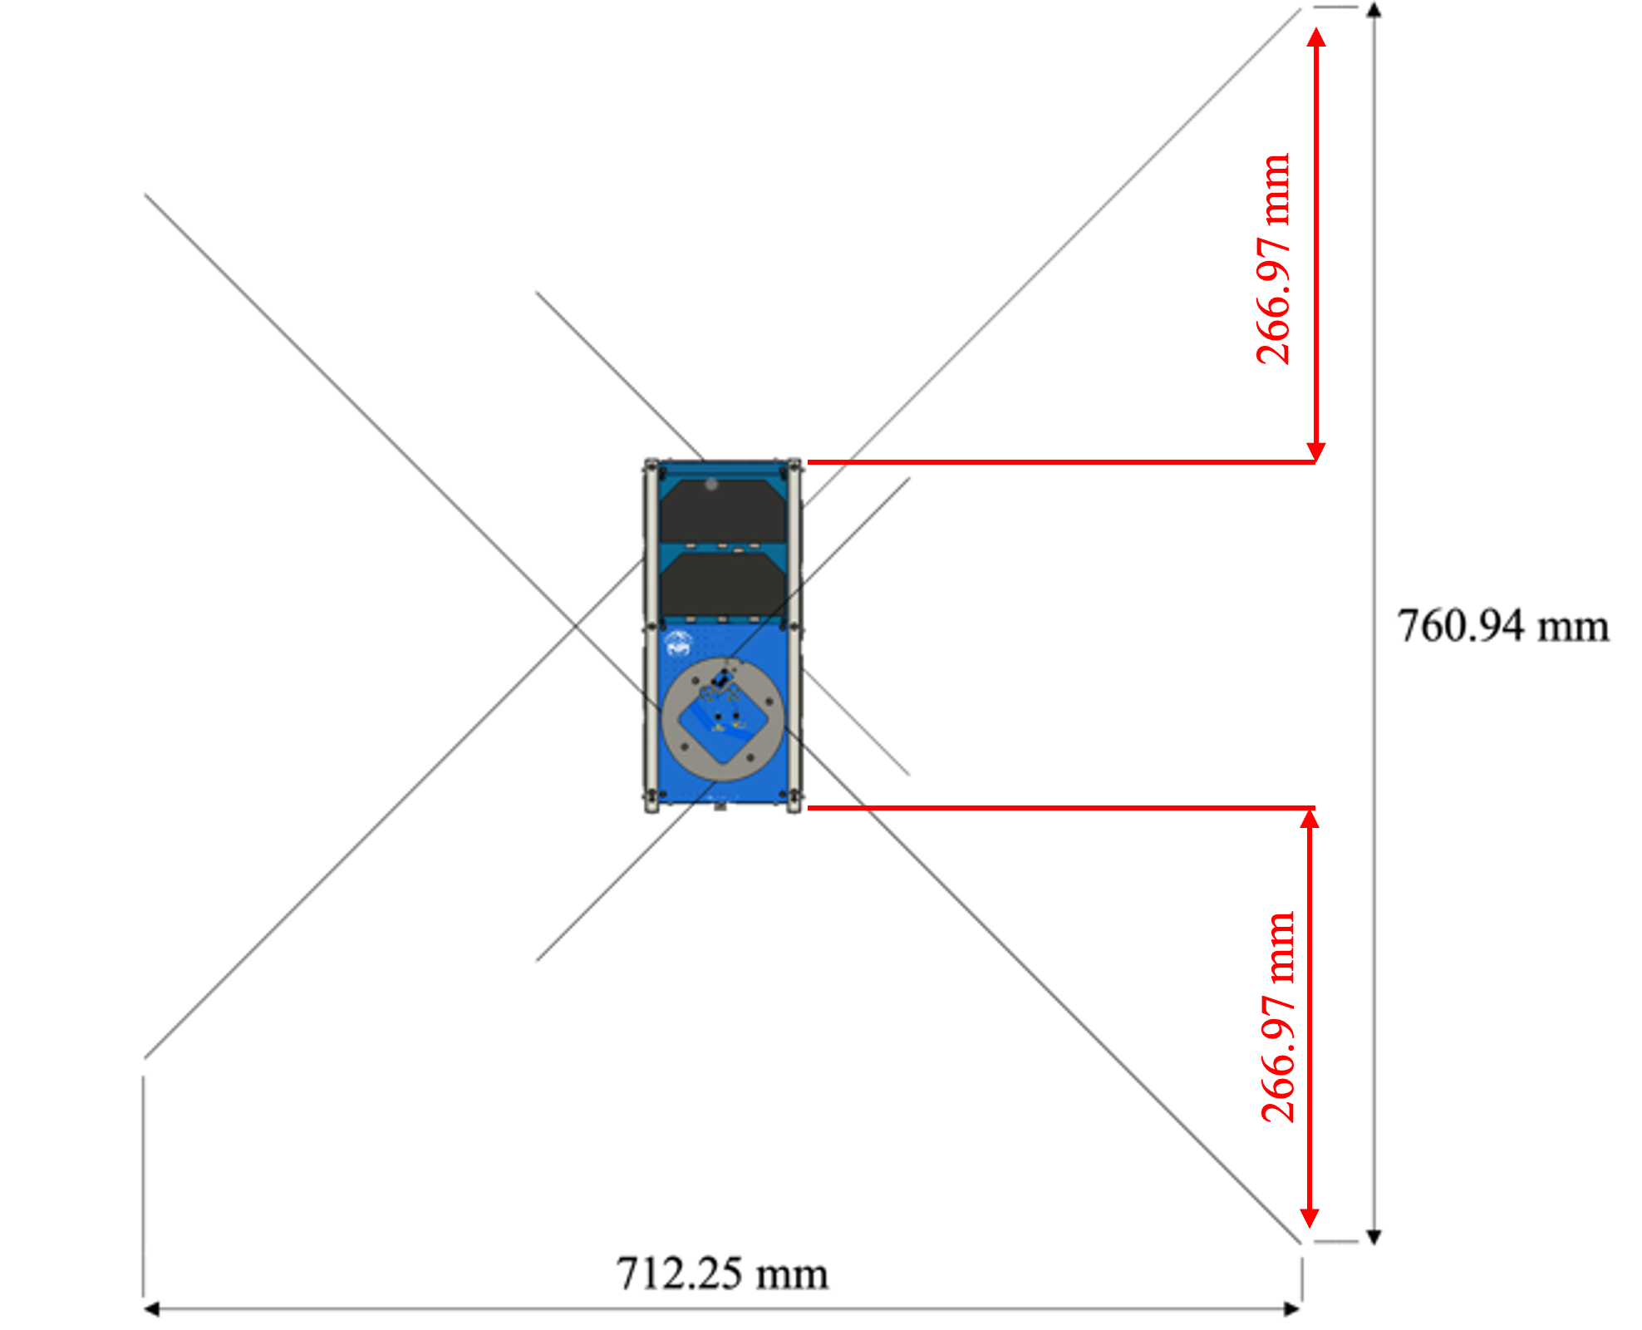

**Figure C-9-1 Deployable antenna distance from CubeSat rail surface**

**Appendix C-10 Leakage current evaluation**

The inhibit circuit of the BIRDS Bus has the circuit configuration shown in Figure C-10-1. The MOSFET (SepSW2) on the battery GND side is operated by turning the transistor ON and OFF with DepSW2. Considering the bias resistance inside this transistor, etc., closing DepSW2 in Figure C-10-2, causes current to flow through the bias resistance, etc. We analyzed the leakage current from the battery when two inhibit switches fail.

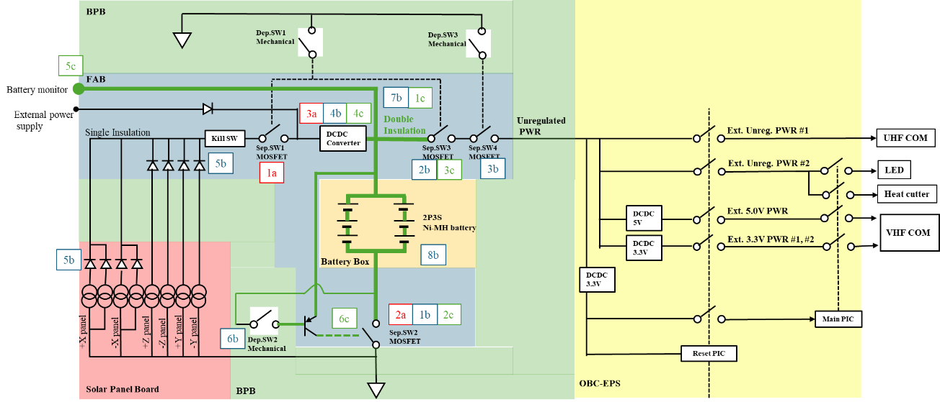  
**FigureC-10-1 Inhibit diagram**

**If DepSW1 and DepSW2 have an ON fault**

Calculate the discharge current when DepSW1 and DepSW2 is turned on.

When DepSW1 is turned on and connected to GND, leakage current flows through the resistor placed in front of SepSW3 and FET in the DCDC convertor.

The following assumptions are made in the calculation.

・The main consumption currents are assumed to be I1 to I6.

・The bias resistance inside the transistor ranges from 33kΩ to 66kΩ, but as a worst-case scenario, R5, R6, R7, R8=33kΩ is assumed.

・R1, R2, R9, R10=1kΩ, R3, R4, R22, R32=100kΩ, R17=100kΩ, R21=430kΩ

・The battery voltage is assumed to be constant at 3.6V.

・Leakage current of the FET in the DCDC converter is 10 µA from the specification sheet (Table C-10-1)

**Table C-10-1 Electrical characteristics of DCDC convertor**

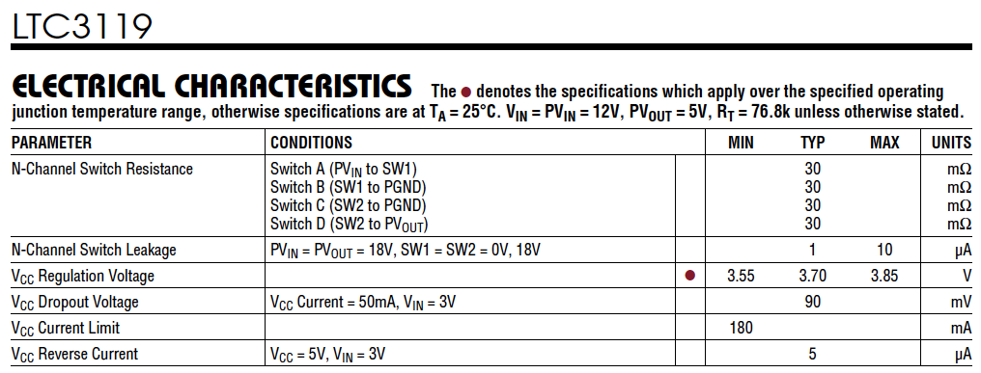

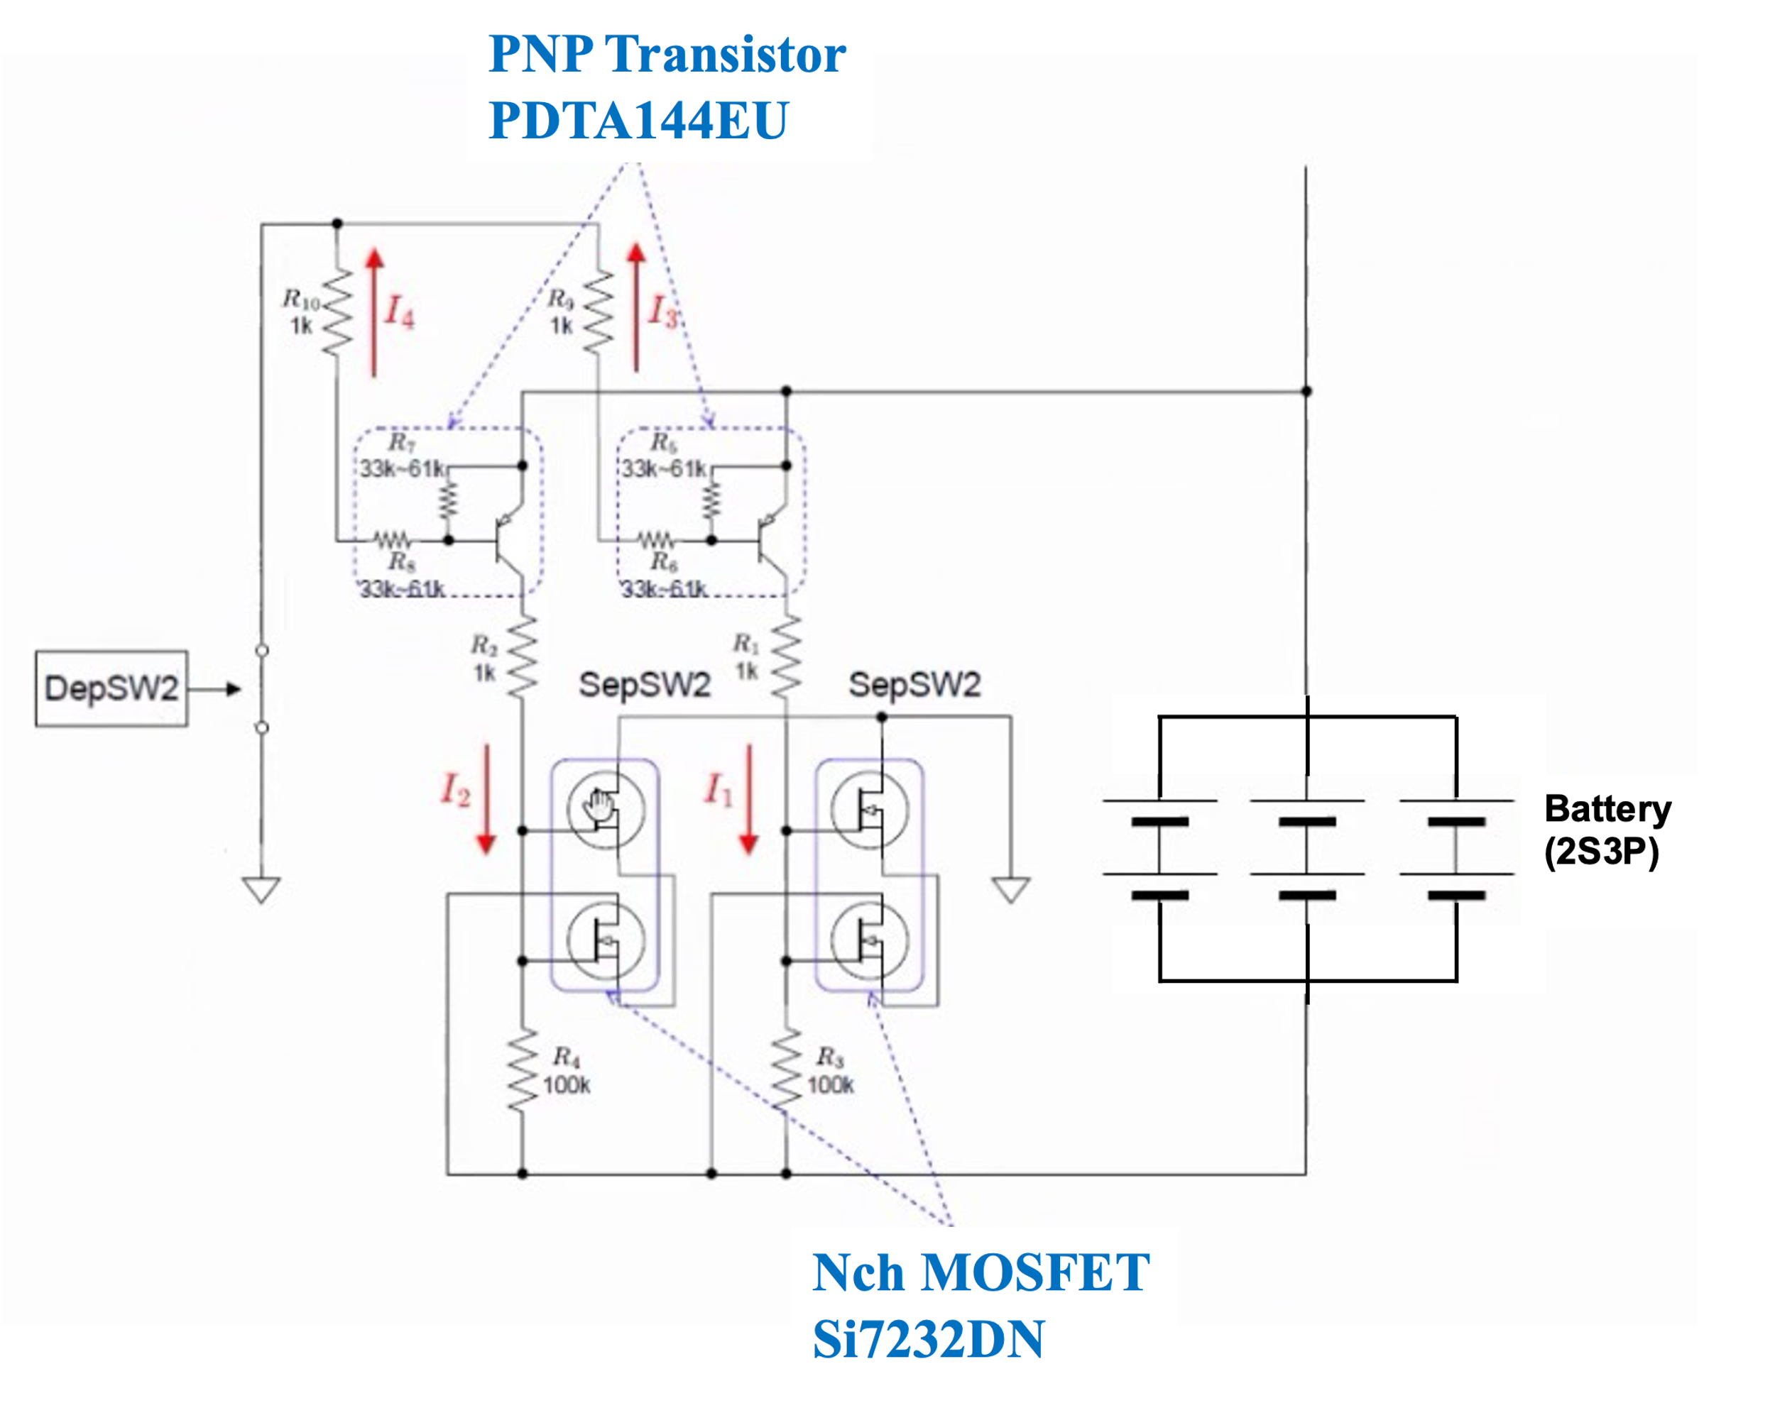

**Figure C-10-2 Detail of the separation switch on GND side**

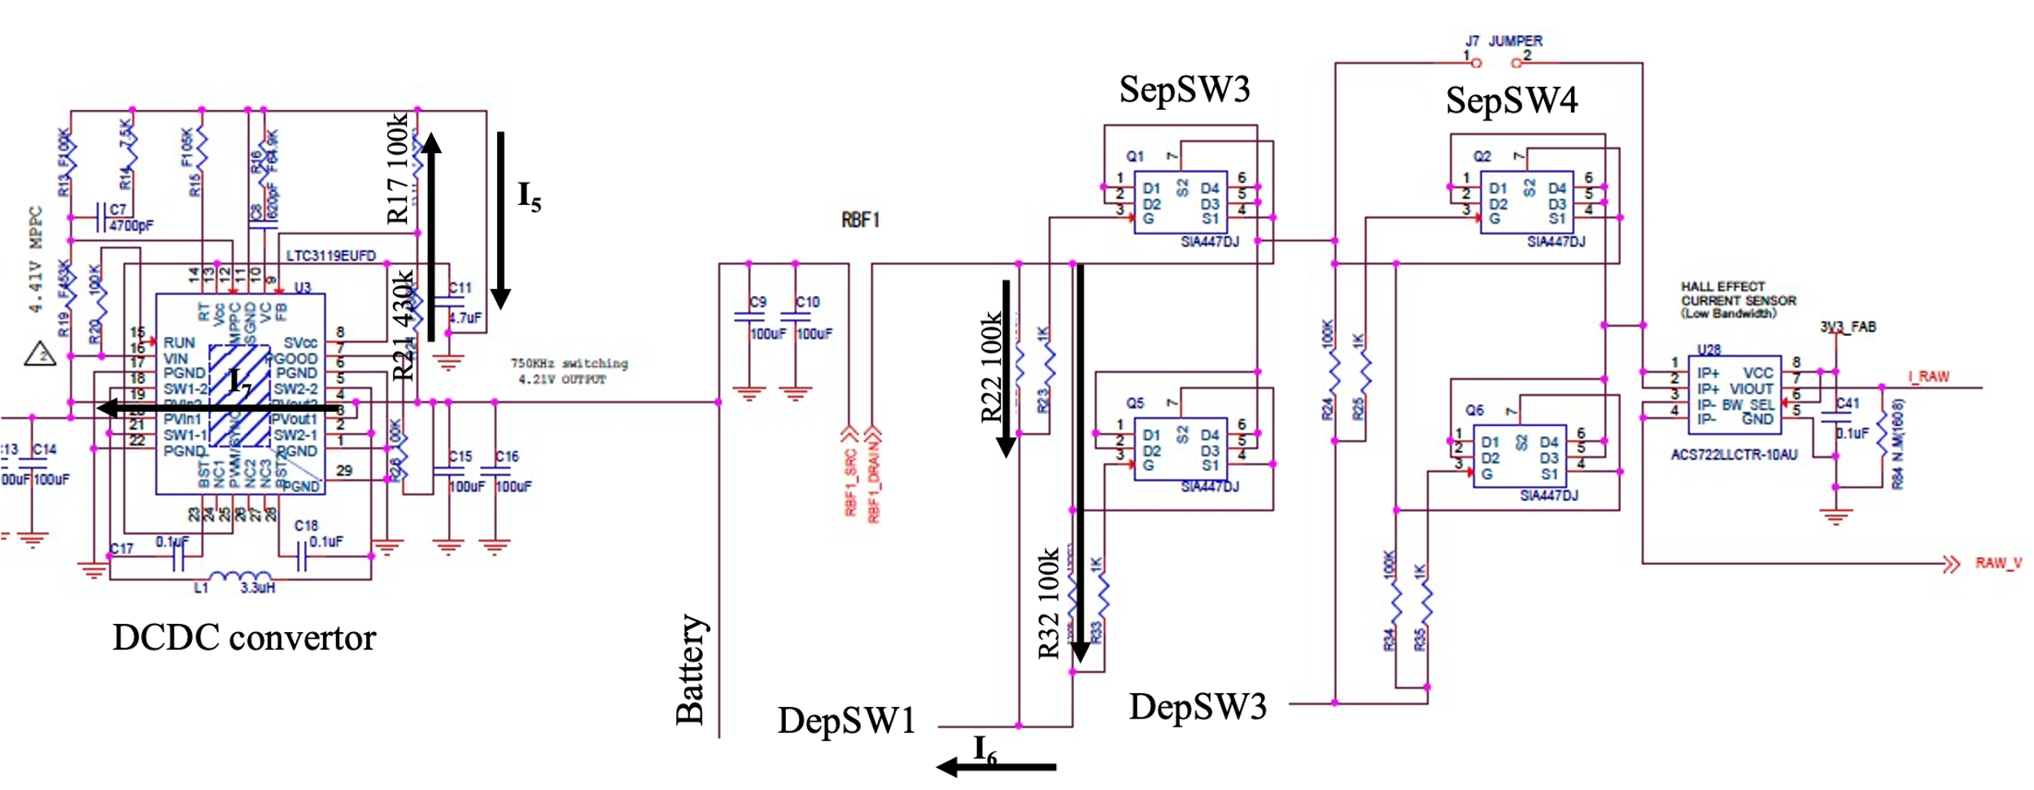

**Figure C-10-3 Detail of the separation switch on HOT side**

$$I_{１}=\frac{V_{Bat}}{R_{1}+R_{3}}=\frac{3.6}{{10}^{3}+{10}^{5}}=35.6×{10}^{-6}$$

$$I_{2}=\frac{V_{Bat}}{R_{2}+R_{4}}=\frac{3.6}{{10}^{3}+{10}^{5}}=35.6×{10}^{-6}$$

$$I_{3}=\frac{V_{Bat}}{R_{5}+R_{6}+R_{9}}=\frac{3.6}{{33×10}^{3}+{33×10}^{3}+{10}^{3}}=53.7×{10}^{-6}$$

$$I_{4}=\frac{V_{Bat}}{R_{7}+R_{8}+R_{10}}=\frac{3.6}{{33×10}^{3}+{33×10}^{3}+{10}^{3}}=53.7×{10}^{-6}$$

$$I_{5}=\frac{V_{Bat}}{R_{17}+R_{21}}=\frac{3.6}{{100×10}^{3}+{430×10}^{3}}=6.79×{10}^{-6}$$

$$I_{6}=\frac{V_{Bat}(R_{22}+R_{32})}{R_{22}R_{32}}=\frac{3.6({100×10}^{3}{+100×10}^{3})}{{100×10}^{3}×{100×10}^{3}}=72×{10}^{-6}$$

$$I_{7}=10×{10}^{-6}$$

$$I_{total}=I_{1}+I_{2}+I_{3}+I_{4}+I_{5}+I_{6}+I_{7}=267.39×{10}^{-6}[A]$$

The total leakage current Itotal is about 0.268 mA. The capacity at which the battery reaches over-discharge is 4,000 mAh, so if the battery is discharged from a full charge, it takes the following number of days for the battery to become over-discharged.

$$t=\frac{ 3800}{0.268}=14.18×{10}^{3}\left[h\right]≈590[day]$$

This number of days is well more than one year from satellite delivery to release. The calculations assume a fully charged battery at rated capacity. In an actual battery, the time until over-discharge is expected to be somewhat shorter than this calculation result, but it is still considered to be sufficient.

**Appendix D Safety Verification Tracking Log (SVTL)**